**Lab 8**

**Branching , Nested loop,**

**Repeat Until**

**(Program** will take input until user press capital A)

. model small

.stack 100h

.code

start:

mov ah,01

repeat:

int 21h

cmp al, 'A'

jne repeat

mov ah,4ch

int 21h

end start

**While loop**

.model small

.stack 100h

.data

.code

start:

mov dx,0

mov ah,01

int 21h

while_:

cmp al, 0dh

je end_while

inc dx

int 21h

jmp while_

end_while:

mov ah, 4ch

int 21h

end start

**Branching**

**IF THEN**

**( if condition is true it print e otherwise it terminate)**

.model small

.stack 100h

.code

start:

mov al,49

CMP al, 49

Je then ; no, exit

NEG AX ; yes, change sign

jmp exit

then:

mov ah, 02

mov dl, 'E'

int 21h

jmp exit

exit:

mov ah,4ch

int 21h

end start

**IF THEN ELSE**

**CASE**

.model small

.stack 100h

.code

start:

mov ah,01

int 21h

cmp al,49

je odd

cmp al,51

je odd

cmp al,50

je even1

cmp al,52

je even1

jmpend_case

even1:

mov dl, 'e'

jmp display1

odd:

mov dl ,'o'

jmp display1

display1:

mov ah,02

int 21h

end_case:

mov ah, 4ch

int 21h

end start

**Lab 8**

**OR (Create a program using OR condition) OR = when both condition are true.**

.model small

.stack 100h

.code

start:

mov ah,01

int 21h

cmpal,'Y'

je then

cmp al, 'y'

je then

then :

mov dl, al

mov ah ,02

int 21h

jmpendif_

endif_:

mov ah,4ch

int 21h

end start

**AND (create a program using And logic means when both conditions are true than program will execute otherwise it terminates)**

.model small

.stack 100h

.data

.code

start:

mov ah,01

int 21h

cmpal,'A'

je endif_

cmp al, 'Z'

je endif_

mov dl, al

mov ah ,02

int 21h

jmpendif_

endif_:

mov ah,4ch

int 21h

end start

**Nested loop**

The concept of using two loops together. Inner and outer

**Program**

.model small

.stack 100h

.code

start:

mov cx,4

l1:

;mov dx,4

mov dx,49

mov ah,2

int 21h

mov bx,cx

mov cx,5

l2:

mov dx,50

mov ah,2

int 21h

loop l2

movcx,bx

loop l1

mov ah,4ch

int 21h

end start

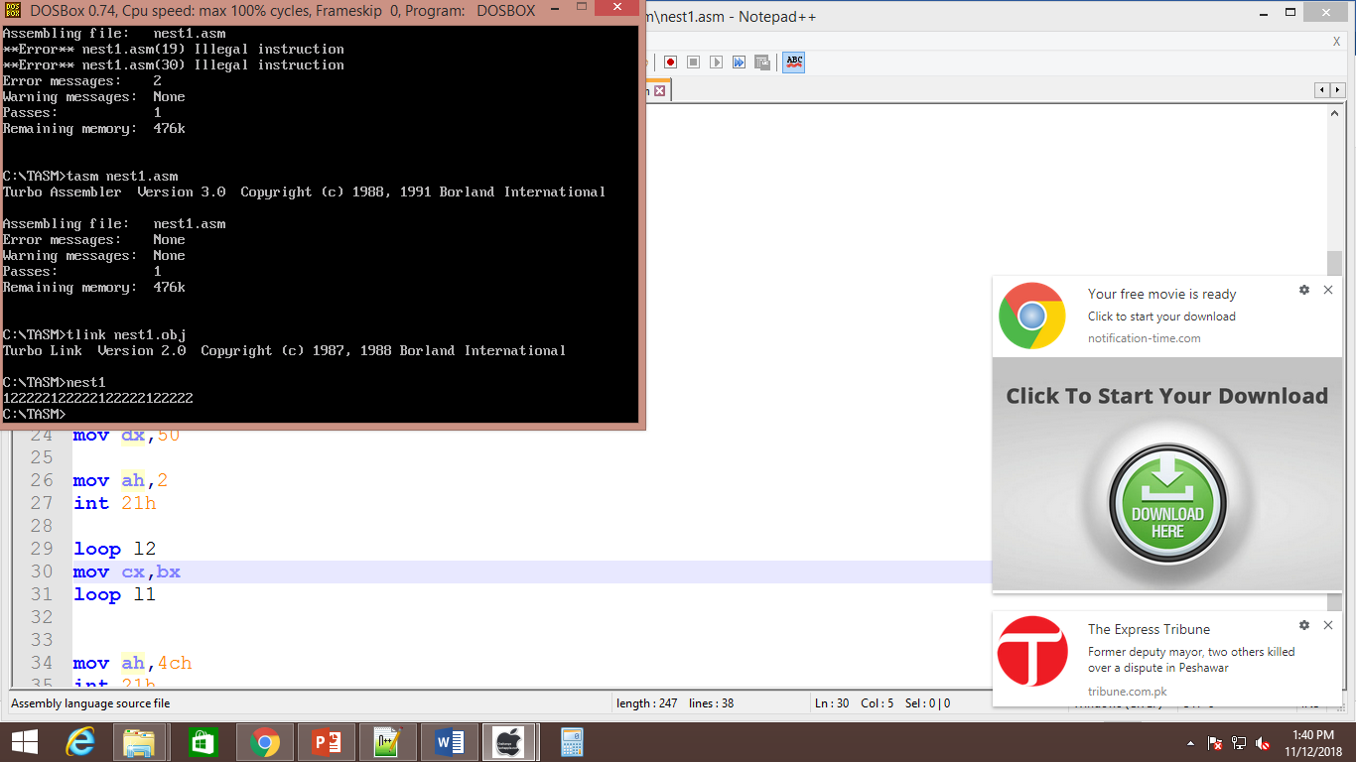

Note:: Alternative way to produce above output.

Program :

.model small

.stack 100h

.code

start:

mov dh, "1" ; ASCII=49

mov cx, 3

outerLoop:

mov ah, 02h

mov dl, dh ; Successively "1", "2", "3"

inc dh

int 21h

movbx, 3

innerLoop:

mov ah, 02h

mov dl, "2" ; ASCII=50

int 21h

decbx

jnzinnerLoop

dec cx

jnzouterLoop

mov ah,4ch

end start

Task : create pattern with help of nested loop

Program

.model small

.stack 100h

.code

start:

mov cx, 4

l1:

mov bx,cx

l2:

mov dl,'*'

mov ah,02

int 21h

loop l2

mov ah, 02

mov dl, 0ah

int 21h

mov ah, 02

mov dl, 0dh

int 21h

mov cx,bx

loop l1

mov ah, 4ch

int 21h

end start

Output

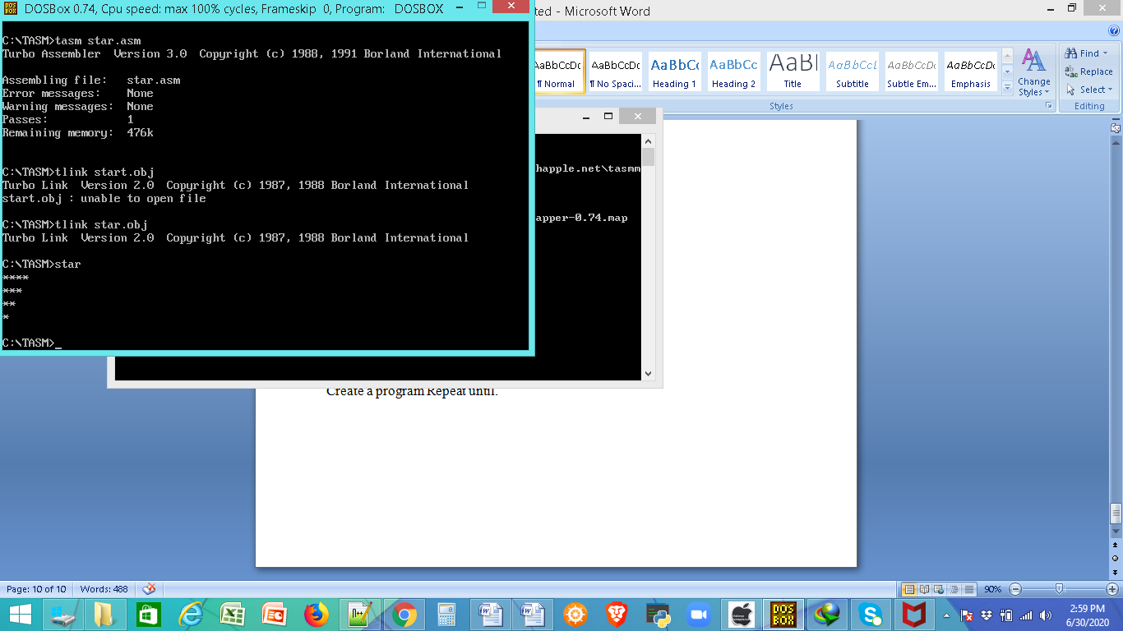

**Task:**

Create program Using AND or OR logic.

Create a program using Case with your own logic

Create a program Repeat until.